Exercise 2

2: (1) When $γ$ =3 and initial condition is *p*1 = *p*2 = *p*3 = 0*.*1.

This is the plot of p1, p2 and p3 with t

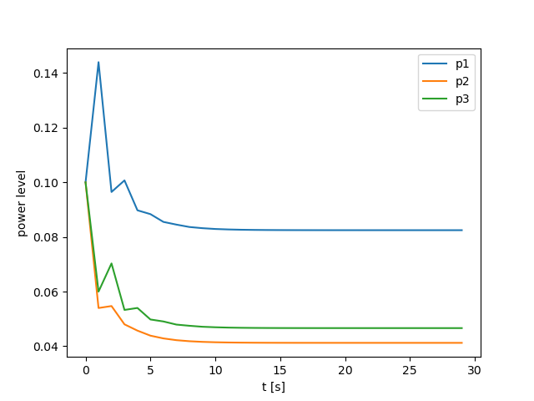

This is the plot of S1, S2, S3 and desired SINR with t

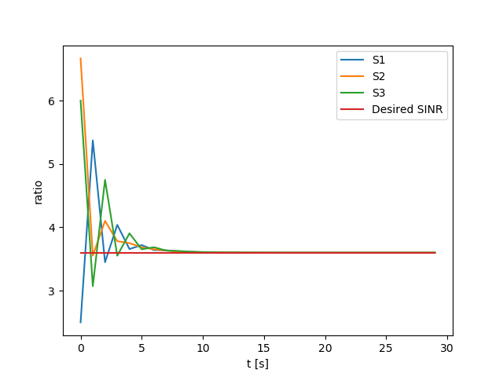

As for the final values of S1, S2 and S3, they are really close to the Desired SINR. So, I think the controller achieve the goal to force *Si*(*t*) *→ αγ.*

(2) When $γ$ =3 and initial condition is *p*1 =0.1, *p*2 =0.01, *p*3 = 0*.*02

This is the plot of p1, p2 and p3 with t

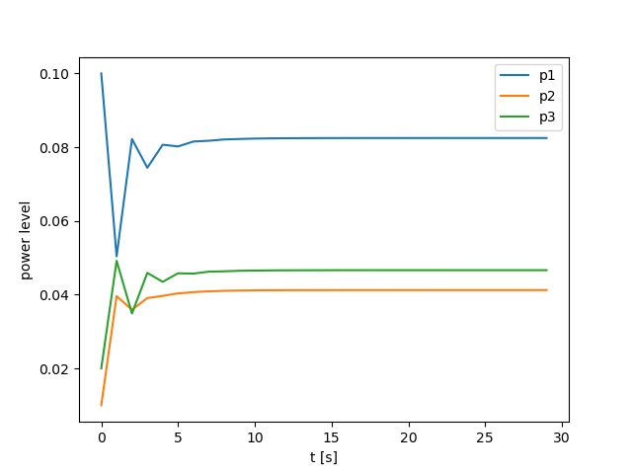

This is the plot of S1, S2, S3 and desired SINR with t

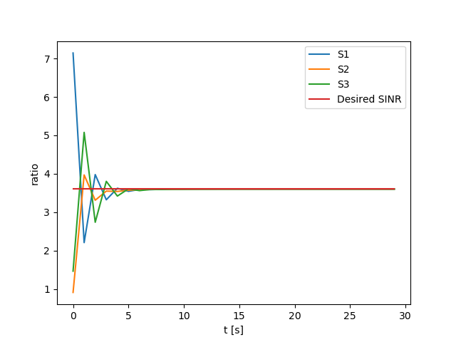

As for the final values of S1, S2 and S3, they are really close to the Desired SINR. So, I think the controller achieve the goal to force *Si*(*t*) *→ αγ.*

(3) When $γ$ = 5 and initial condition is *p*1 = *p*2 = *p*3 = 0*.*1.

This is the plot of p1, p2 and p3 with t

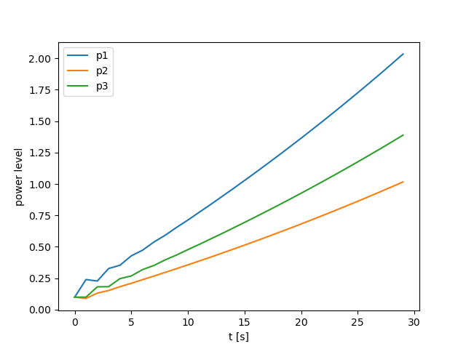

This is the plot of S1, S2, S3 and desired SINR with t

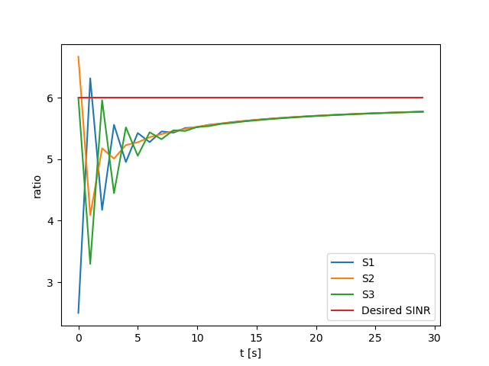

As for the final values of S1, S2 and S3, they are close to the Desired SINR. So, I think the controller achieve the goal to force *Si*(*t*) *→ αγ.*

(4) When $γ$ =5 and initial condition is *p*1 =0.1, *p*2 =0.01, *p*3 = 0*.*02

This is the plot of p1, p2 and p3 with t



This is the plot of S1, S2, S3 and desired SINR with t



As for the final values of S1, S2 and S3, they are really close to the Desired SINR. So, I think the controller achieve the goal to force *Si*(*t*) *→ αγ.*